Restart Your Health Goals

Drop-In Article
To Use: Customize this article by filling in the highlighted portions with specific details about your program. Once you’ve filled in the article, you can post it to your organization’s website, publish it in your organization’s newsletter, and/or send it to a local newspaper or magazine.

Revisit, Refresh, and Restart Your Health Goals

When is the last time you thought about your health goals? Whether it was last week, last month, or even last year, now is the time to revisit your goals and restart healthy habits that you may have put on hold.

Getting back into a routine after time off can seem overwhelming at first, but you can do it. Start by thinking about how far you’ve already come. Consider the challenges you’ve likely faced and the success you achieved along the way. Both have helped you build up the skills you need to achieve your goals. Instead of thinking about time lost, focus on the future and everything that you’ll be able to accomplish!

Here at [name of program], [part of CDC’s National Diabetes Prevention program OR a CDC-recognized lifestyle change program], we want to help you revisit, refresh, and restart your healthy lifestyle goals by following the steps below.

Revisit: Begin by revisiting your goals. If you are part of a lifestyle change program, your goals may already be written down. If not, try to remember the last time you set goals for yourself and what they were. It might be helpful to write them out. An example of a goal might be to add vegetables to at least two of your meals and snacks during the day or to go for a 30-minute walk 4 days a week.

Refresh: Once you’ve revisited your past goals, it’s time to refresh them! This is a chance to think about where you are currently and what you want to accomplish in the future. This may have changed over time. Read over your past goals and think about the following:

- Do these goals still make sense for me?
- What worked and what didn’t work well for me in the past?
- What issues have caused or may cause me to get off track?
- Are there any changes I want to make to my goals going forward?

You will also want to write down three actions that you can do to achieve each goal. For example, if your goal is to add vegetables to at least two of your meals and snacks during the day, your three actions could be: browsing online recipes for inspiration, planning out your meals before you go to the grocery store, and washing and prepping vegetables so they're ready to eat throughout the week. Remember, your actions should be:
- Realistic: Be practical about what you can achieve
- Doable: Plan for small changes that add up over time to bigger changes
- Specific: Plan your action in detail by deciding who, what, where, when, why and how
- Flexible: Review your plan often and make changes if something isn’t working

Restart: You’ve got your goals and your action plan that outlines the steps you need to take for success. Now it’s time to put them to the test and try. If they work, keep going! If you find yourself having difficulties, don’t give up! Pause and reexamine. Revisit your goals, refresh, and restart. The most important thing is to set attainable goals and actions that work for you so that you can achieve better health.

[Note: If you have resources on your website that can help people plan and achieve their goals, include them here.]

As you work toward your refreshed health goals, remember to seek out support from those around you. Support from your family, friends, and coworkers will encourage you and help keep you on track. If you haven’t already, you can also join a lifestyle change program, like [name of program]. At [name of program], a trained lifestyle coach works with a group of participants to help them learn how to eat healthier, exercise more, and reduce stress. The class is specifically designed for people who have prediabetes, a condition where a person’s blood sugar levels are higher than normal, but not high enough yet for a type 2 diabetes diagnosis. With support from the lifestyle change coach and each other, participants have been shown to cut their risk of developing type 2 diabetes in half. If you have or are at risk for prediabetes and would like more information, contact us at [insert contact information].

Sample E-Newsletter Copy
To Use: You can use this copy when sending online e-newsletters, specifically through email distribution. Customize this article by filling in the highlighted portions with specific details about your program. Consider placements in a community newsletter, local health care provider or network newsletter, or faith-based newsletter.

Jumpstart Your Healthy Habits!

When is the last time you thought about your health goals? Whether it was last week, last month, or even last year, now is the time to revisit those goals and jumpstart healthy habits that you may have put on hold.

Getting back into a routine after time off might seem overwhelming at first, but you can do it. Instead of thinking about time lost, focus on the future and everything that you’ll be able to accomplish!

You can revisit, refresh, and restart your healthy lifestyle goals using the steps below.

Revisit: Begin by revisiting your past goals. If you haven’t already, put them down on paper and make them official.

Refresh: This is a chance to think about the future and what you want to accomplish – which may have changed over time. Read over your goals and think about the following:

- Do these goals still make sense for me?
- What worked and what didn’t work well for me in the past?
- What issues have caused or may cause me to get off track?
- Are there any changes I want to make to my goals going forward?

Write out your refreshed goals, making any changes that you think are needed. You will also want to write down three actions that you can do to achieve each goal. Remember, your actions should be:
- Realistic: Be practical about what you can achieve
- Doable: Plan for small changes that add up over time to bigger changes
- Specific: Plan your action in detail by deciding who, what, where, when, why and how
- Flexible: Review your plan often and make changes if something isn’t working

Restart: Now it’s time to put them to the test and try. If you find yourself having difficulties, don’t give up! Pause and reexamine. Revisit your goals, refresh, and restart. The most important thing is to set attainable goals and actions that work for you so that you can achieve better health.

[Note: If you have resources on your website that can help people plan and achieve their goals, include them here.]

As you work toward your refreshed health goals, remember to seek out support from those around you. If you haven’t already, you can also join a lifestyle change program, like [name of program]. At [name of program], a trained lifestyle coach works with a group of participants to help them learn how to eat healthier, exercise more, and reduce stress. The class is specifically designed for people who have prediabetes, a condition where a person’s blood sugar levels are higher than normal, but not high enough yet for a type 2 diabetes diagnosis. With support from the lifestyle change coach and each other, participants have been shown to cut their risk of developing type 2 diabetes in half. If you have or are at risk for prediabetes and would like more information, contact us at [insert contact information].

Social Media Copy and Images

Post Copy | Recommended Image
When is the last time you thought about your health goals? Make it today! Revisit your goals and restart healthy habits you may have put on hold. [Insert link to your website or the link to the drop-in article once it’s posted online] | 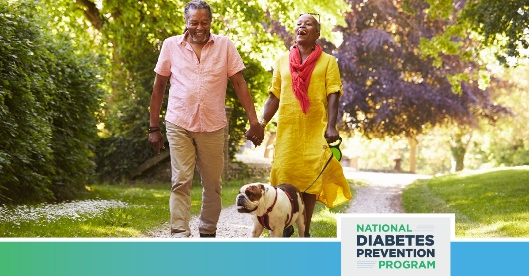
Picking healthy habits back up after time off can seem overwhelming at first, but you can do it! Focus on the future and everything that you will be able to accomplish on the road to better health.  [Insert link to your website or the link to the drop-in article once it’s posted online] | 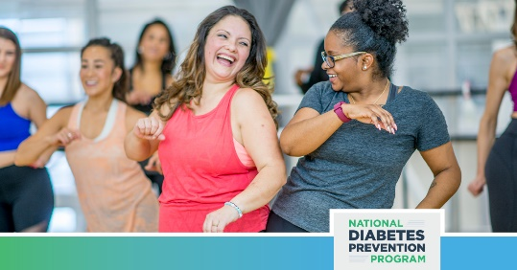
We all face challenges and roadblocks on our path to better health, but don’t give up! Make time to revisit, refresh and restart your health goals today. [Insert link to your website or the link to the drop-in article once it’s posted online] | 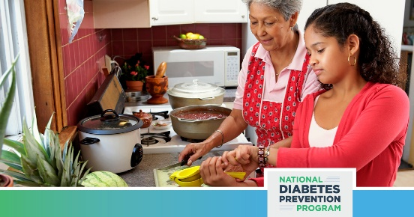
To Use: You can post the sample copy and suggested images below on Facebook, Twitter, and Instagram. Feel free to include your own links as needed. These images (and other options) are available for download on the National DPP Photobank on AMP.

